Parables of Our Lord
2018 VACATION CHURCH SCHOOL

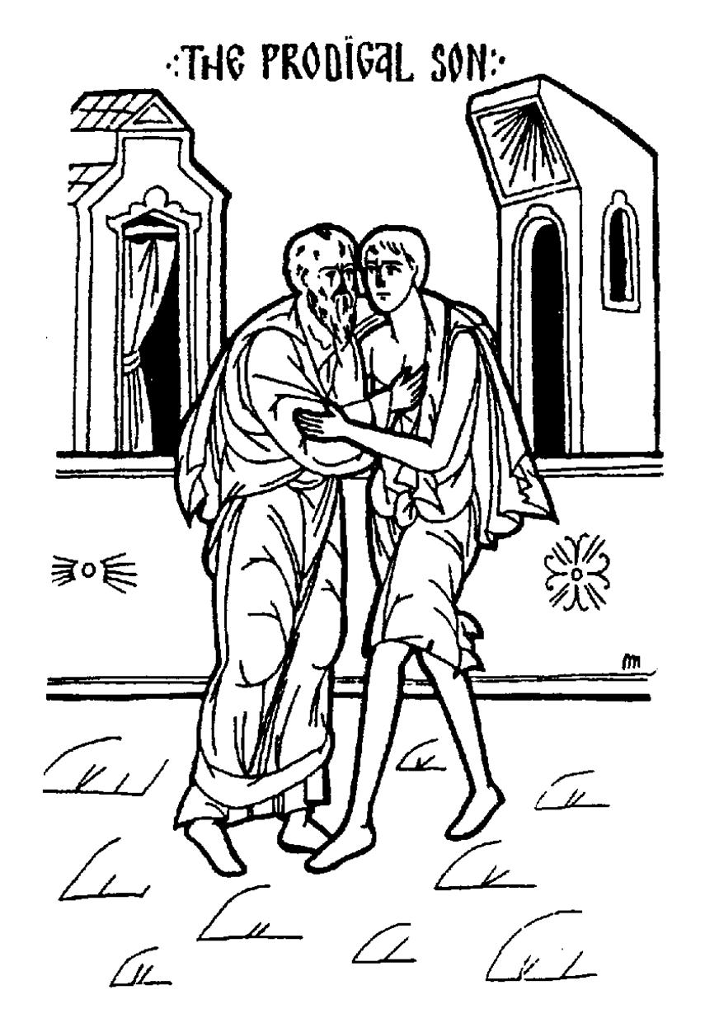
June 4-7
(Monday – Thursday)
9 AM – 12 PM
Ages 3-12
Please join us for VCS this year!

Daily Schedule

8:45 - 9:00 Registration (Monday only)
9:00 - 9:30 Morning Prayers
9:30 - 10:15 Daily Lesson
10:15 - 10:30 Snack Break
10:30 -12:00 Daily Activities – music, crafts, outdoor play

Price – $15 per child - includes T-shirt & snacks
(Please do not allow the cost to keep your children from coming! For financial assistance, see Fr. Justin.)

……………………………………………………………………………………………………………
St. Athanasius Orthodox Church, 100 Lime Lane, Nicholasville, KY

